**Lecture 1: Financial Management Overview**

**Goal of Financial Management:** TO MAXIMISE SHAREHOLDER WEALTH/MAXIMISE STOCK PRICE/MAXIMISE FIRM VALUE/MAXIMISE CONTRIBUTION TO THE ECONOMY by making 3 decisions:

|  |  |
| --- | --- |
| **Capital Budgeting Decision**: process of planning and managing a firm’s LT investments [↑ size of pie] | -What **LT investments** (fixed assets) ?  -Size, timing, risk of future cash flow.  -Identify inv opp worth > cost to acquire. |
| **Capital Structure Decision:** mixture of LT debt and equity maintained by firm [how best to slice up pie] | -How the firm get **LT financing** for required investment? CL, LT debt and Shareholders’s Equity  - % → creditor  - % → shareholders |
| **Working Capital Management:** firm’s short term assets and liabilities | -How much ST cash flow company need to manage liquidity and the **everyday financial activities**?  NWC = CA-CL (How much inv, AR, CL) |

**Sole Proprietorship**: Easy to start, few regulations, Single owner keeps all the profits, Taxed once as personal income, unlimited liability  
**Partnership:** ≥2 owners; Taxed once as personal Income, Relatively easy to start, unlimited liability, dissolves when 1 partner sells/dies, difficult to transfer

**Company:** Limited Liability, Separation of ownership & mgt, Unlimited Life, Ease of raising capital& transferring ownership [BOD, elected by shareholders to rep them - selects mgt team, appoints auditors, responsible for checking mgt’s actions.]

**Agency Problem**: COI between principle and agent; Direct costs such as expenses which benefit management (car, house), indirect costs eg: lost opportunities; **Combat by** – compensation plans tied to share value, direct intervention by shareholders, more monitoring, threat of firing etc  
**Lecture 2: Financial Statement Analysis**

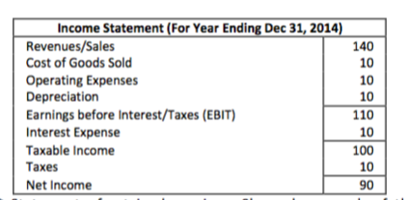

**CFFA: ($ generated from operations over the period)=OCF-NCS- in NOWC**

**OCF:** Cash flow that results from firm’s day-to-day activity of producing and selling (*don’t include depreciation, amortization, interest like Note Payable*)  
**No I/r Exp**: CFFA=CF to Creditors+CF to Stockholders

**I/r Exp**: CFFA =CF to Creditors+CF to Stockholder – ITS (↑cash to creditors)

**Interest Tax Shield (ITS):** ↓ in amt of taxes paid = Interest paid x Tax Rate

**CF Stockholders:** div paid-net new equity raised(end common stock – beg cs)

**CF Creditors**: interest paid to creditors-net new borrowings   
*(interest bearing borrowings-Long term liabilities & notes payable)*

**OCF**=EBIT+Depreciation-(EBIT*TaxRate) or Net income+Dep (no interest) or (sales-cost)(1-tax)+DE(tax rate)

**Net Capital Spending (NCS)**=Ending FA-Beginning FA+Depreciation

**in NOWC**=Ending NOWC-Beginning NOWC

**Operating working capital (NOWC)**=CA-CL(w/o interest); includes operating cash, inventory, A/R, accounts payable (*exclude interest bearing* financing: Short term loans/debt, Notes payable)

*Debt ratio↑ 🡪 L↑ (due to ↑loan🡪↑int exp) or A↓ (due to ↑dep exp) 🡪NI↓, PM↓)*

**Net working capital (NWC**)= CA-CL

**Liquidity ratio:** ability to meet SR obligations: pay bills in SR

* **Current Ratio: Current Assets/Current Liabilities**
* **Quick Ratio: (Current Assets – Inventory) / Current Liabilities**
* **Cash Ratio: Cash / Current Liabilities**
* **NWC to Total Assets Ratio: Net Working Capital / Total Assets**
  + Low value → low liquidity
* **Interval Measure (days): Current Assets / Average daily operating costs**

**Financial Leverage Ratio/ LT solvency Ratios:** *extent of relying on debt financing rather than equity. ↑ debt more likely to default**/ ↑ potential reward to stockholders*

* **Total Debt Ratio= Total Debt(liabilities)/ Total Assets**
  + Lower better
* **Debt Equity Ratio=(Total Assets-Total Equity)/Total Equity**
* **Equity Multiplier Ratio = TA / Total Equity = Debt equity ratio +1**
* **Long Term Debt Ratio = LT Debt/(Long Term Debt + Total Equity)**
  + (LT debt+TE) = total capitalization(not assets)
* **Times Interest Earned Ratio = EBIT/Interest paid (higher better)**
* **Cash Coverage Ratio = (EBIT + Depreciation) / Interest paid**

**Asset Management/Utilization Ratio(Activity ratio) (turnover/efficiency):**

**Inventory Ratio:** *how quickly inventory produced & sold*

* **Inventory Turnover: COGS/Inventory (higher more efficient)**
* **Days Sales in Inventory==**

**Receivable Ratio:** *success of managing credit collection from customers*

* **Receivables Turnover= Sales/Receivables=**
* **Day Sales Outstanding==**

**Fixed Asset&TA Turnover:** *effectiveness is using assets to generate sales*

* **FA Turnover=Sales/Net Fixed Assets (replace old equip with new one, or sub labour for equip will increase NFA and lower this ratio)**
* **TA Turnover (TATO)=Sales/Total Assets**
* **NWC Turnover=**

**Profitability Ratio:***how successful a business is in earning returns on its investments. Combined effects of liquidity asset management and debts ; ↑higher better*

* **Profit Margin = Net Income/Sales**
* **Basic Earning Power = EBIT/Total Assets**
* **ROA = Net Income/Total Assets (Higher debt, higher interest expense, lower NI, lower ROA. Debt also lowers equity, if equity lowered more than net income, ROE will increase)**
* **ROE = Net Income*/Total Common Equity (downside is ROE only focuses on return not risk, does not consider amt of capital invested)**

**\* If there are preferred dividends: Net Income -preferred dividends**

**The Dupont System:** *profitability & efficiency measures*

**ROE**=

**Market Value Measures:** *relate firms stock price to earnings, cash flow and book values; ↑higher better!*

* **P/E Ratio: Price/Earnings per share (earnings per share is firm NI/no. of shares)**
  + how much investors are willing to pay for $1 of earnings

Price-sales ratio=

* **Market to Book Ratio=**
  + how much investors are willing to pay for $1 of book value equity
  + compare mkt value of firm’s investments to cost;
  + <1 = firm not successful overall @ creating value for stockholders
* **Dividend-Yield Ratio=**
* **Dividend-Payout Ratio=**

**Lecture 3: Time Value of $**

**Annuity Due**: series of same CF in which first CF occurs immediately

**PV Annuity Due**=PV Ordinary Annuity * (1+r)

**FV Annuity Due**=FV Ordinary Annuity * (1+r)

**Perpetuity:** Set of equal PMT that are paid forever (no “last PMT”)

**PV of perpetuity**==

**PV of growing perpetuity**= ,r>g

**Effective Annual Rate(EAR):** the actual rate paid/received after taking into consideration any compounding that may occur during the year. If interest is compounded more than once a year, stated rate (APR)<EAR. If compounded once a year; stated rate=EAR

**EAR**=, m=cpding freq/yr

**Annual Percentage Rate(APR):** Nominal Annual Rate/ Quoted rate/Stated rate

**APR**= Period rate*no. of periods per year (EAR≥APR)

if interest and payment have different period, use given APR (m=interest period) to find EAR and use this EAR to find updated APR(m=payment)

Eg. Borrowed $1000. Pay $10 every month for a year.

EAR = (1+0.01)12 – 1 = 12.68%

**Period Rate**= ,

- the more often you compound, ↑EAR but caps at

**Types of loans:** Pure discount loans (interest and

Loans paid at maturity), Interest only loan(

Interest paid throughout, principle at maturity),

Fixed principle payments( same amount of

principle paid and diff amounts of interest) ,

Ammortized loans ( equal installments paid throughout, Fixed PMT)

**Lecture 4: Risk&Return I**

**Dollar term/ Dollar return:** Amount received – Amount Invested

% term:

**Dividends(Income) yield**= (cannot be negative)

**Capital Gains Yield**= (can be +ve/-ve; unrealized till share is sold)

*Capital Gain of asset price increasing from $4 to $10 is 6 dollars*

**% Returns** = (Nominal. No inflation considered.)

**Real Rate of Return:** 1+**real return**= (Fisher eqn);

Approximate Real Return: Nominal Return – Inflation Rate

**Real Risk Premium =**

Calculate **Arithmetic Average Return** (Use historical data on asset)

Estimated **SD** using **historical data** *– realized rate of return at any time t.*

Total Risk, σ: larger the risk, larger SD, actual returns will be far away from mean

Measure of coefficient of variation(CV): standardized measure of dispersion about expected value, risk per unit rate of return (better measure of risk)

or

Lower **risk per unit of expected return** if CV lower.

Risk premiums: return over and above risk-free rates (“extra” return earned for taking on risk) =expected rate–risk free rate(T-bill)

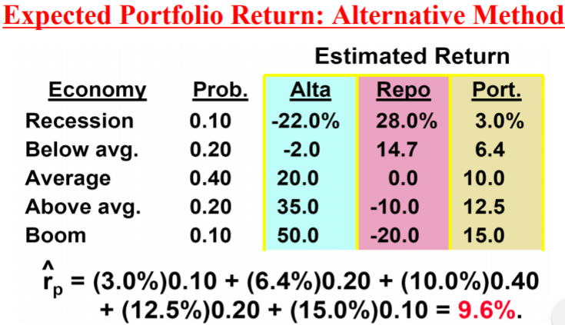

**Expected Portfolio σ**: Find σ, treat portfolio as 1 stock, CVp same

Portfolio Risk Premium based on market risk.

**Portfolio risk (scenario)** = return of port for that scenario

**Covariance:**

**=++…+}/(i-1)**

=**correlation coefficient** between X and Y

* + - * When -ve, covar of variables -ve. Diversification benefit when combined

**Covariance**: interaction btw indiv stocks w one another

measures extent to which X and Y move tgt & variance of portfolio depends on the correlation coefficient between the assets included in the portfolio.

standardises the units of covariance measure

🡪In general 1-1; Risk of pf gets smaller as **ρ → - 1.0**

If **ρ**=-1.0, 2 stocks can form a riskless portfolio 🡪 move opposite direction

If **ρ**=+1.0, there is no reduction of risk for the 2 stock portfolio 🡪 move together

When p =1 or -1,

If **ρ**= 0, there is no correlation between 2 stocks 🡪 do not move together

**σ, Total Risk** = Company-specific (Unsystematic Risk) + Market (Systematic) Risk

**Unsystematic Risk**: caused by events specific to firm/industry. Diversifiable.

**Systematic Risk:** affects most if not all firms. Cannot be diversified away.

**Market Risk of an Investment**: measured by covariance of Investment’s return with returns of the market then divided by market portfolio variance

Market portfolio, **=1**; **=0**; =0 if =0 (doesn’t react with market)

If <1 🡪less systematic risk than market

If >1 🡪 more systematic risk than market

🡪 shows a stock’s volatility relative to market: Indicates how risky a stock is if the stock is held in a well-diversified portfolio

**Geometric Av. Returns vs Arithmetic Av. Returns**

**Geo Av. Returns**: What one actly earned per year on average compounded annually; mean holding period return; average compound return earned per yr over a multi-year period; avg cmpd return per yeaer

**Lecture 5: Risk&Return II**

**Well diversified portfolios**: little unsys risk, Total risk =sys risk=

**Systematic Risk Principle:** Expected return on a risky asset depends only on β.

measures the responsiveness of a security to movements in the market portfolio; the amount of systematic risk present in a particular risky asset relative to that in an average risky asset. [Slope of regression line of asset’s return on mkt pf return]

**:** based on historical data, cannot determine future risk

**Portfolio’s Beta, βp =** is the weighted average of the assets betas.

* + - * βp will not be lesser than all individual β in the pf
      * For portfolio w randomly selected stocks, βp = avg of β of ind assets
      * Can reduce β by selling common stock & buying T-bills

**β** is not fixed: depends on which time period you use; daily, weekly, monthly returns, Beta of a company may change over time

**Market Risk Premium/Reward to risk Ratio = (RM – RF)** (slope of SML)

**Nominal risk premium=Nom return - Nom risk-free**

**Real risk premium=Real return - Real risk-free**

**Security Market Line(SML):** Graphical representation of the CAPM, market equilibrium; slope= reward to risk ratio (Rm-Rf); describes risk-return r/s between β of a security and it’s required rate of return

* Assets below SML are **overpriced** and assets above SML are **underpriced**
* Required return<Expected return (**underpriced**)
* Required return>Expected return (**overpriced**)

**Reward to risk ratio** =

* Reward to risk ratio > market risk premium **(under valued**)
* Reward to risk ratio < market risk premium **(over valued)**

**Capital Asset Pricing Model:** equation describing SML defining the relationship between market risk and required return.

* Determine the required return (used to price physical/financial asset).
* can be used on both single assets and portfolios

**Required return,**

: Pure time value of $ - reward for merely waiting for your $ w/o taking any risk

**:** Reward(Risk Premium) – for bearing systematic risk; **:** Systematic risk; Market risk premium – rewards the market offers for bearing an average amount of systematic risk.

**Higher risk premium → greater expected returns**

**Larger β → higher sym risk → greater expected returns**

* + - * If fairly priced/in eqm, highest R = highest β

Expected return = Required return (if market efficient)

**Parallel shift of SML**: Change in capital market condition eg, rate of inflation, high econ growth (real ) , capital market tightens (real

* + - * Ri for each stock in mkt will by an amt = in mkt-risk premium
      * Stock price changes when info isn’t anticipated by public, even if only affect LT future. ( inflation, stocks mkt price cos real R , demand , stock price )

**Change in slope of SML**: Change in investor attitude towards risk that affects market risk premium (risk aversion) risk adverse= more daring

* + - * Ri for stock w β of 0.5 will by an amt < in mkt-risk premium

**Movement along SML**: risk level of individual changed (due to change in risk sources eg biz, finance risk) higher up → higher risk

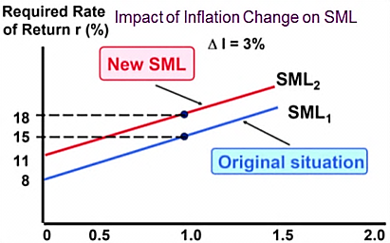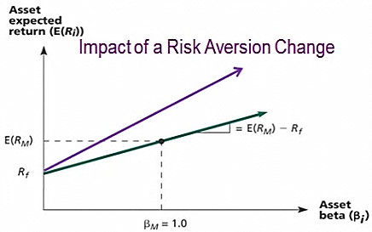

**Efficient portfolio:** greatest expected return for a given lvl of SD(risk) or lowest risk for given expected return.

**Efficient frontier:** line representing all efficient portfolios.

* + - * Not efficient once a risk-free asset is available to borrow/lend (riskless borrowing or lending)



**Lecture 6: Bond Valuation**

**Bonds** are long term(>1 year) debt instruments sold to raise money**.** Bonds are *fixed-income investments*, and thisregular income is what makes bonds *less* volatile than stocks.

**Bond owners:** creditors of the company and not owners (unlike stockholders)

**Coupon Rate:**  stated annual coupon i/r(**fixed**)

**Par:** Face value of a bond (principal amt) that will be repaid at maturity

**Callability:** issuer can redeem bond before it expires→higher risk

**Putability:** buyer can redeem bond before it expires

**Subordinated debt**: junior debt → higher risk→higher coupon

**Basis Points:** measures of differences in yields. **1 basis point = 0.01%or1/10000**

**Bond Indenture(“deed of trust”):** Bond contract specifying principal, coupon, maturity, amt of bonds issued, right and duties of buyers, backing assets/securities, sinking fund, call provisions, protective covenants

**Relationship of YTM&Bond Prices**: ↑i/r(YTM)→bond PV↓→ bond prices↓

**YTM > Coupon Rate**(Discount):bond sells below par value: I/R↑,YTM↑,P↓

**YTM < Coupon Rate**(Premium):bond sells above par value: I/R↓,YTM↓,P↑

**Sinking Fund: Pool of money set aside to help repay bond issue**

**Bond Value : PV of coupons (annuity) + PV of Par (lump sum)**

**Overall rate of return**

**Bonds of similar risk & maturity:** priced similarly regardless of coupon

* + - * Same return/YTM (Premium bonds pay higher current I while having Px dep as maturity nears)

**Bond prices and time:** Tend towards face value as time increases  
**% Current yield = Coupon per year / Bond price** (current mkt px)(doesn’t take into acc any capital gain or loss associated with principal to be paid at maturity)

**Discount Bonds: Coupon Rate < Current Yield < YTM (<$1000)**

**Premium Bonds: Coupon Rate > Current Yield > YTM(>$1000)**

**Par Value: YTM = Current Yield = Coupon Rate = $1000**

* if inflate i/r by 2%, YTM ↑ 2% (I/Y value)

**Coupon rate < discount rate, discount bond and vice versa**

**Zero coupon bonds -> If compared to semiannual bond, use semiannual too**

↑Maturity, Lower coupon rate, ↑i/r risk

**Put bond:** bondholder can force the company to buy the bond back prior to maturity (*Lower required return)*

**Lecture 7: Stock Valuation**

**Book Value:** Price paid on acquiring asset less *accumulated depreciation*

**Market Value:** Price of an asset as determined in competitive marketplace

**Intrinsic Value:** What an asset is really worth: PV of all future cash flows

* Determined by *amount, timing and riskiness of CF* & CAPM r
* If market is efficient: intrinsic value = market value

DIVIDEND GROWTH MODEL

1. **Constant Dividends (0 growth) :** Constant div forever, *perpetuity*.

rE =cost of equity, required return frm CAPM

1. **Constant Dividend Growth Model:** Best suited for firms w LT stable growth (net income), growing at a constant rate, g. Growing perpetuity.

, D1 = dividend in 1 year time

- just paid dividend = last dividend = D0

- **Gordon Growth Model**: price grows at same rate as dividends

**=expected rate of return = dividend yield+capital gains yield**

1. **Nonconstant Growth:** For dividend ≠constant growth →count individual PV, for dividend = constant growth→find terminal value →PV:1 time period before constant growth e.g. from t=3 onwards

**RE:** required return under *market* eqm condition= **CAPM=Rf+(RM-Rf)β =**

**Market value of firm**: PV of all future CFFAs(Find terminal value if there is g)

**Market value of common stock:** PV of future CFFAs**–**Market value of firms debt and preferred stock (if any) (**USE WACC**: discount rate)

**Share price:** Market value of common stock/no. of shares

**Market Value of Equity**=MV of firm – MV of debt= **Market value of common stock**

**New company(not profitable)**= Pt=Price sales ratio x EPS

Corporate value model preferred over dividend growth model when firms don’t pay dividends or hard to predict dividends.

**Lecture 8: Capital Budgeting I NPV>0**: Cash inflow>Cash outflow

**Internal Rate of Return (IRR) –** Solving for discounting rate that makes NPV=0. Usually give same decision as NPV. Accept if IRR > Req return

**Modified Internal Rate of Return (MIRR) –**

**Combination: PV of -ve CF (outflows) = FV of +ve CF(inflows)/(1+MIRR)n (compound using WACC to maturity and then discount with MIRR)**

Correctly assumes cash flows are reinvested at WACC & avoids problems of multiple IRRs. Not truly an “internal” rate of return. No real need to consider reinvestment of CFs. **Accept if MIRR > Req Return**

**PayBack Period: Initial Cost = 100, Cfs = 10, Payback period = 100/10 = 10yrs**

**Discounted PayBack: Same as Payback but use discounted cashflows**

**AverageAccountingReturn:** Avg NI/Avg Book Value Accept if AAR> preset rate

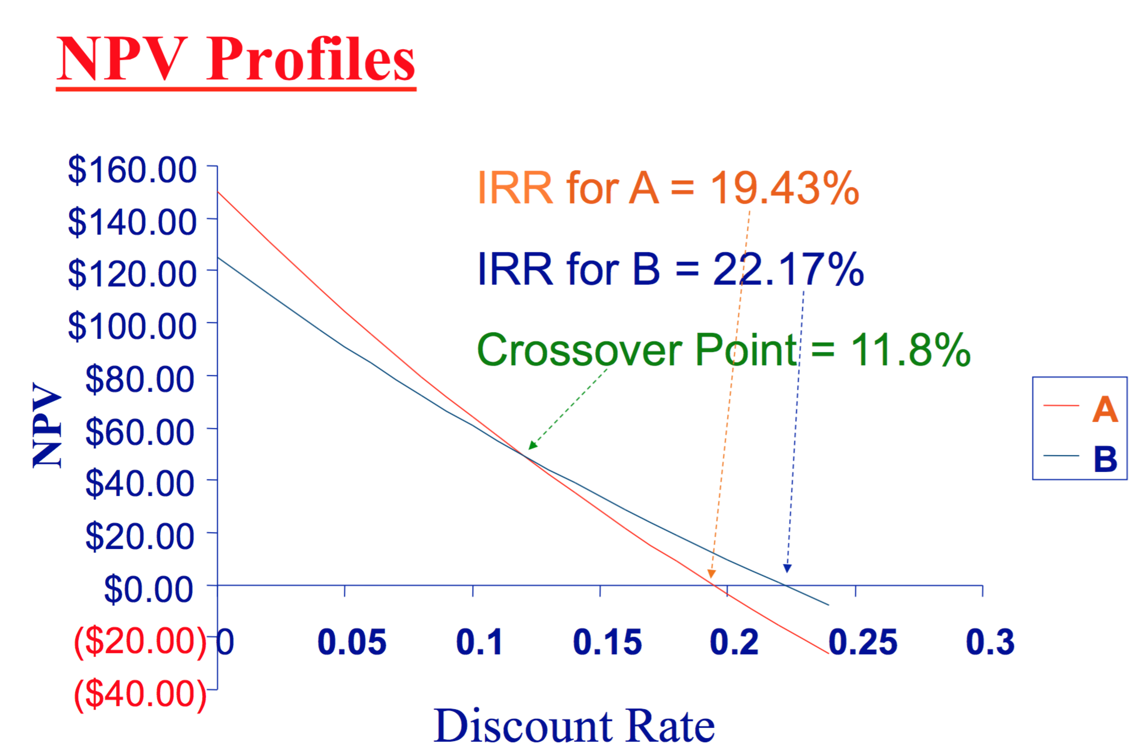

Mutually Exclusive Projects:

Before crossover: NPVA>NPVB

After crossover: NPVA<NPVB

Indifferent at crossover point

Conflict between NPV&IRR:

A has higher NPV but lower IRR: pay back slower

Slope: Short-term project B is steep🡪smaller compounding

**Crossover Point:** Equate both NPV eqns together/Use the difference between both sets of CFs as the Cfs to enter in CF worksheet. Then, IRR=crossover point

**Profitability Index = Total PVs of future CFs/Total Investment = Outlay+NPV/Outlay.** choose highest PI, **Accept if PI > 1**

NPV=0, PI=1

**Lecture 9: Capital Budgeting II**

(All cash flow measured in after tax basis)

**Ignore: Financing Costs e.g. interest, dividends(alrdy in WACC), Sunk Costs**

**Relevant: Opportunity cost. Externalities. Changes in NOWC. Taxes**

**WACC = rD( 1 – Tax rate) * D /V + rE* E/V (rE is derived from CAPM)   
D=Debt (market value)=No of bond*P0 of each bond found with ytm**

**E=Equity(market value)=No. of shares outstanding*Price of each stock**

**V=D+E rD:** required Rate of return on debt **Tc  = marginal corporate tax rate**

**4. Terminal Year Cash Flows**: *Salvage value received*(net of taxes) & *returned NWC*

OCF = EBIT + Depreciation – EBIT (Tax Rate) 🡪 No interest expense

**Methods for calculating OCF:**

1) Bottom-Up Approach (works only if no interest exp)

**OCF = NI + Depreciation (NI=Sales-Cost-Depreciation-Taxes)**

2) Top-Down Approach(do not subtract non-cash & interest expenses)(works only without interest)

**OCF = Sales – Costs – Taxes**

3) Tax Shield Approach(work for both[ w or w/o i/r expense)

**OCF = (Sales – Costs)(1 – T) + Depreciation*T (cost=FC&VC≠depre) take the changes**

Net Cash Flow = OCF – NCS - ∆NOWC

Net Capital Spending = END net fixed assets – BGN net fixed assets + Depreciation

* (Can be negative when sale of investment greater than new purchases: sell>buy)

Depreciation Tax Shield = Depreciation*Tax Rate (lower taxes payable)

Straight line depreciation taking salvage into account = [(Initial cost-Salvage Value)]/no.of years]

Full Depreciation/ Depreciation to zero: Initial Cost/Years

**After tax salvage value** **(S>B)=Gain on sale** = S – T*(S - B) **(S<B)=Loss on sale= S+ T*|S-B|**

Book Value(B)= Initial cost-Acc depre (Depreciation*No of years)

Replacement project (Salvage Value forgone)  
1)Find the OCF: Cost Saving, Incremental Depreciation, EBIT, taxes [OCF= EBIT (1-tax) + DE]  
2)t=0:Calculate net S value on old machine (inflow) & Cost of new machine (-outflow) This gives NCS (net capital spending for terminal year)

3)t=end: Find Net S value on new machine - net S value on old machine (opp cost)

OCF every year, NCS in Y0 , Opp cost (-ve), New SV(+ve new) = NCF

For Mutually Exclusive Unequal Life Projects, use Equivalent Annual Annuities (EAA)

→ Assume each project will be replaced an infinite no. of times in future

→ Ignores the effects of inflation, changing economic conditions, unreliable estimates of cash flows due to possible effects of technology improvements

**1) Find NPV 2) Use NPV as the PV, Find EAA (PMT), 3) Select project**

→ **Higher EAA** is better for **cash inflows,**

→ **Lower EAA** is better when comparing **costs**

If NPV is positive, EAA is a cash inflow; If NPV is negative, EAA is a cash outflow

**Chapter 10: Financial Planning and Forecasting**Percentage of Sales Approach: Do up pro-forma statements

\***Assume** that FS items such as assets, costs and current liabilities (A/P) are usually proportional to sales, A/P vary; NP, LT debt and equity do not vary usually

1) if want maintain D/E ratio, dividend is plug: debt and equity also grow by x%, 2) if don’t want dividends, debt is plug ; **↑RE=NI-Div**

1. **Additional Funds Needed (AFN) Equation/External (EFN):**

**AFN = (Assets/S0)∆S – (L/S0) ∆S – M (S1)(RR)**

**Values of Assets and Liabilities use original values NOT projected increase**

* **S0:** Sales during the past year, **S1**: Sales projected for the coming year
* **M** (profit margin) = Net Income/ Sales **M(S1)(RR)= increase in owner’s equity**
* **Assets:** assets increase with sales **L**: Liabilities increase with sales, AP, exclude NP

**RR**(retention ratio)= 1 – (Dividend / Net Income)= Addition to RE/ NI

**Dividend Payout Ratio** = Dividends / NI

**Important Assumptions for using AFN Equation:**

**1) Firm is operating at full capacity ∆sales→∆asset**

**2) Constant Profit Margin, RR, Dividend Payout Ratio, capital structure**

**If AFN > 0, can either: (TA>(TL+E))**

i) Borrow more short term debt(Notes payable), more long term debt

ii) Sell more common stock

iv) ↓ dividend payout, which ↑ RE= NI-Dividend

**If AFN < 0, can either: (TA<(TL+E))** 🡪 excess $, opposite actions

AFN doesn’t account for change in rate of return to shareholders

Pro Forma Income Statement:

**- If the PM** is assumed to be constant→**costs vary** directly with **sales.**

**- Interest:** Doesn’t vary with sales.

**- Dividends:** conscious decision by the mgt, do not vary directly w sales.

Pro Forma Balance Sheet**:**

**- assume all assets& Accounts payable:** vary directly with sales **- Notes payable, LT debt and equity:** generally do not vary with sales as they are conscious capital structure decisions by the management.

**- ∆in RE →** come from dividend decision **- Current Assets:** always vary directly with sales (unless stated) **- Fixed assets:** only vary directly w sales when operating at full capacity. **Capital Intensity Ratio = Total Assets / Sales = 1/TATO**

**=** Amt of assets to generate $1 in sales

Growth and External Financing: *Assumption: **all L are non-spontaneous**

**Internal Growth Rate** – how much firm can grow assets using Retained Earnings as the only source of financing (internally generated funds)

Proof using **AFN = Spontaneous increase in Assets – 0 - Increase in RE (L = 0). The answer will be 0.**

**IF growth = Internal Growth rate → AFN = 0**

**Average Equity:** Beg+end/2 → end equity = beg equity+NI-Dividends

**Sustainable Growth Rate:** how much firm can grow by using internally generated funds and issuing debt to maintain constant debt ratio - maximum growth rate w/o external equity financing [SGR>IGR since ROE > ROA]

* + - * When calculate SGR, all AFN financed by debt to maintain D-E ratio.

**Determinants of Growth:** Using Dupont Identity ROE = PM * TATO * EM

i) Profit Margin –> Operating Efficiency = **Net income/Sales**

ii) Total Asset Turnover – >Asset use Efficiency = **Sales/total Assets**

iii) Financial Leverage –> Choice of Debt Ratio = **EM = 1+Debt/Equity**

iv) Dividend Policy: how much to pay to shareholders vs reinvest in firm

**Use AVERAGE values except for TATO**

**USE ROE X B if beginning balance sheet numbers are given instead.**

**Operating Capital (OC)** = NOWC + Net FA

**Free Cash Flow** = NOPAT – Net Investment in OC

**Capacity Sales** = Actual Sales / Current % of Capacity

**Target Ratio** = FA/Capacity Sales

**Change in FA** = Target Ratio x Exceeded amt of capacity sales

Lecture 11: Working Cap Management:$avail 4 daily activities (ST debt & opp cost)

**Gross Working Capital:** Current Assets

**Balance Sheet Identity: NWC + Fixed Assets = LT Debt + Equity**

**Cash =** Equity (inclusive of RE) + LT debt + CL – CA(other than cash) – FA

**Inventory period:** time required to purchase & sell inventory

**AR Period(DSO):** time to collect credit sales

**AP Period**/payables deferral period: Time period need to finance inventory

**CC:** Difference between receiving cash from sale and paying for inventory. **Minimizing cash cycle ↓ the amount of external financing needed.**

**Payables Turnover:** Total purchase from suppliers/average payable OR(COGS + End inventory – Beginning Inventory)/Average Payable

**Accounts Payable Period: 365/Payables Turnover**

**↓CC:** ↓AR period/↓inventory period(JIT-↑efficiency of machine/↑inventory turnover)/↑AP period (-ve CC when AP>op cycle)

Aim:minimize CC

↓CC → ↓TA → ↑ROA → ↑ROE

For Inventory and Receivables, use average. (Beginning + Ending)/2

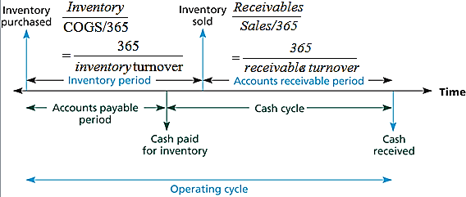

-ve cash cycle:suppliers financing(receive cash x days before paying)

**Effectiveness of Working Capital Policy is reflected in Current Ratio, Turnover of Cash and Securities, Inventory Turnover and DSO.**

Excess WC: conservative policy/inefficient(buffer stocks/a lot of inventory)

↑Cash Cycle 🡪 Excess WC may not be bad if translate to↑profitability

**Carrying Costs** costs of storing and financing current asset:↑with↑CA

**Shortage Costs** costs of replenishing assets:↓with↑CA. E.g. Order cost, lost sales and customers/production stoppages/lost of customer goodwill

**Lockboxes** help to turn A/R more quickly and make it easy for customers to pay.

**Float:** Bank -Book balance  **Net Float = Disbursement Float + Collection Float**

**Disbursement Float =** Amt of checks written × total delayto clear **bank > book**

= available balance at bank – book balance (+ve)

**Disbursement:** Benefits firm as more money to earn interest

• Controlling disbursements

– Zero-balance account: another checking acc(1 master account🡪1safetystock)

– Controlled disbursement account: max amt a day(pay on that day immediately)

• Stretch out accounts payable as long as possible: negotiate

• Turn receivables as quickly as possible: lockboxes/prepaid envelops/discounts

**Collection Float =** Amt of checks received × total delay for check to clear **bank < book** = available balance at bank – book balance (-ve)

**Cost of collection float**: opportunity cost of not being able to use $$

**Size of float affected by:** (1) $ amt (2) time delay = delay x float

**Aver. Daily Float** = Average daily receipts x weighted average delay

**If only one receipt**, for example, 1 $1000 & 5day delay, avg daily float = (5)(1000)/(30)

**Collection delay = Mailing time + processing delay + availability delay**

**Mailing time:** checks trapped in postal system

**Processing Delay**: check receiver to process payment and deposit in bank

**Availability Delay**: time required to clear check through banking system

**Disbursement**: control Mailing time

**Collection float:** Processing delay + Availability delay

**Credit Management:** Trade off between increased sales & costs of credit

**Accounts Receivable =** Credit sales per day × Length of collection period

**Terms of Sale:** If terms of sale are A/B, net C

**Period rate** = A/(100—A) **🡪 express in %**

**Period** = C-B

**Company benefits:** when customers forgo discounts

**Credit Policy of 4 Variables:**

1) Credit period: with cash discount, CP=Net credit period

2) Discounts for early payments: ↓DSO and attract new customers

3) Credit standards: tighter→↓bad debt;↓DSO (but may↓Sales cos pay earlier)

4) Collection policy: tougher→↓DSO (but↓customer r/s)

Example: Cal EAR when customers do not take the discount

**Credit Terms of 2/10 net 45 = 2% disc if pay in 10 days, or full in 45**

- Period Rate = 2/98 = 2.0408%

N=1, PV=98, FV=-100. CPT: I/Y

- Period = (45 -10) = 35 days

- Periods per year = 365 / 35 = 10.4286

EAR = (1.020408)^10.4286 – 1 = 23.45%

↓ **DSO:** (without reducing sales) **SR**: ↑cash holdings, **LR**: company invests cash in productive assets or pay shareholders ↑ firm’s value

|  |  |
| --- | --- |
| **Revenue Effects of Credit Policy** | **Cost Effects of Credit Policy** |
| Delay in receiving cash from sales | Cost of sale still incurred w/o receiving $ |
| Increase in Total Sales | Cost of debt – financing receivables |
| Increase in price | Probability of non-payment |
|  | Cash Discounts (pay < full price) |

**Incremental Cash Flow = (P-v)(Q1 – Q0)**

**PV of incremental monthly cash inflow =** [(P-v)(Q1 – Q0)] / r

**Cost of switching =** P(Q0) [cash given up] + v(Q1 – Q0) [cost of producing extra]

**NPV of credit policy =** PV of cash inflow – Cost of switching (incremental)

**P** = unit price**, V** = var cost/unit**, Q1** = new qty with policy

Effective Interest Rate of a Compensating Balance:

**(1) Amount required to Borrow:** Amount needed /(1- compensating balance requirement %). If u need 150k and compensating balance = 5%, u actually borrow 150/(1-0.05) = 157.89k

**(2) Find Int paid.** Set N, I%, PV as amt req to borrow. Find FV 🡪 Int paid = FV – PV = **Amt to borrow x Interest rate.** *Example: 157.89k x i/r*

**(3) Find effective rate.** Set FV = original amt + int paid; PV = original amt; N. Find I%. = **interest paid/ amount needed**

**Cash budget: Beginning cash, Forecast: cash inflow, outflow and ending cash balances (surplus/deficit)**

**Cash collection budget:** Begin AR; Sales; Cash collections; End AR

Potential cash inflows: Proceeds from sale of fixed assets, proceeds from stocks and bond sales, interest earned, court settlement; bad debt reduces sales collected

**Cash disbursement budget:** Begin AP; Purchases; Cash payments; End AP

**Cash Balance**: Cash Collection – Cash Disbursement = Predicted net cash inflow

**Cash Collection:** beginning AR + (ARperiod/CF period) x Sales

**Cash disbursement:** beg AP + (APperiod/CF period) x COGS (%sales)

If **AP period=CF period**, COGS of previous mth (unless buy 1 mth b4= current COGS)

Eg:AR Period=10🡪start receiving cash 10 days later;AP Period=30days🡪 start paying 30 days later,Inventory bought 1 mth b4; Dec sales=$600, Jan Sales =$1200

Cash Collection= 10/30*600+ 20/30*1200

Cash disbursement for payable = 0.7*COGS

**Chap 12: Options** Derivative instrument: hedge against risk **100 shares/ contract**

**European Option**: exercised only AT maturity

**Writer and Seller of Call Option**: Obligated to sell/short/write

**Writer and Seller of Put Option**: Obligated to buy/long

Premium of Option = Price of Option = Value of option

**Payoff of call at maturity =** Max [stock price at expiration date –X, 0]

**= CT= MAX{ST - X, 0} CT= Price of call option at maturity**

**Call Holder:** (Market Price > Strike Price, PURCHASE at predetermined P)

* If ST >X, Exercise Call to get ST - X , “in the money”
* If X = S, “At the money”
* If ST < X, Option value/Payoff = 0 , “out of money” (intrinsic=0)

**Put Holder:** Market Price < Strike Price (SELL at predetermined P)

* If ST < X, Exercise Put to get Payoff = (X - ST) “in the money”
* If ST > X, Option value/Payoff = 0 , “out of money” (intrinsic=0)

**Call Writer:** (Strike>Market)

Gain money when people buy options. Losses are dependent on whether options holder exercises the options.

* If ST ≤ X, Payoff = 0
* If ST > X, Payoff = -(ST - X)(-ve)

**Put Writer:** (Strike<Market)

* If ST > X, Payoff = 0
* If ST < X, Payoff = -(X - ST)(-ve)

**Exercise prices < Current Price:** Call options > Put options

**Exercise prices > Current Price:** Put options > Call Options

**Profit to Call/Put Holder**: Payoff – Premium (cost of option to purchase)

**Profit to Call/Put Writer**: Payoff + Premium

**Call Option: Infinite gains/loss**

**Put Option: Max gains/loss is Exercise price (if stock price = $0)**

**Value of Call Option** = C0= = Initial Stock Price – PV of Exercise Price

**Total profit** = (ST – X – Call Price) x 100

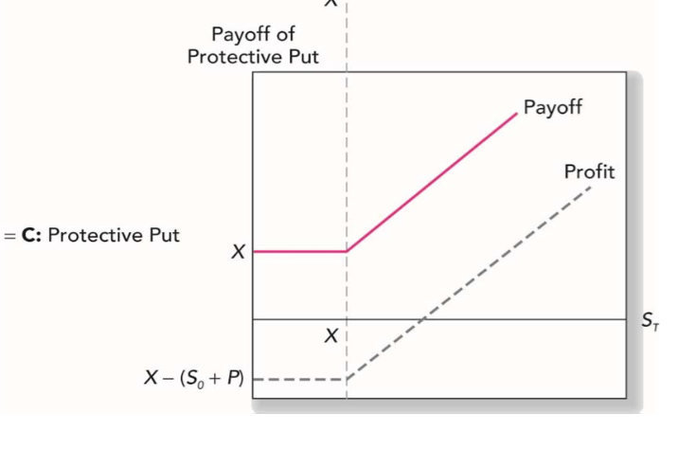**Protective Put with Stocks**

* + - * 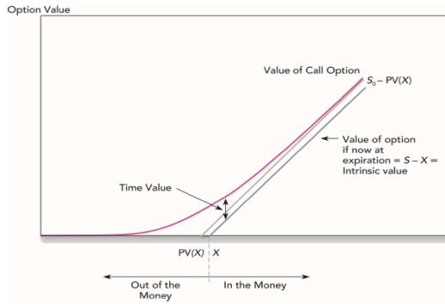buy a stock and buy a put on the stock)

Option value increase with time to maturity & I/r becos PV(X) ↓ 🡪 C0 increase

Option value increase with volatility of share becos payoff not symmetric

**Option value determinants:**

|  |  |  |
| --- | --- | --- |
| **Affects Option Value** | **Call** | **Put** |
| Stock Price | **+** | **-** |
| Exercise Price | **-** | **+** |
| Interest Rate | **+** | **-** |
| Volatility in stock price | **+** | **+** |
| Expiration Date | **+** | **+** |

**Lower bound**: **Intrinsic value** = payoff if option exercised immediately

For call: Max(0, Stock Px -Strike Px); For put: Max (Strike Px – Stock Px)

**Upper bound: Stock price**

**Value of Option must fall within: max (S0 – PV(X), 0) < *C*0 < *S*0 (upper & lower)**

**Time Value of an option**: Option Price – Intrinsic Value (volatility value)

**Arbitrage opportunity:** If not within upper or lower bounds

**For call option:** if priced below lower bound, options holder can exercise the call immediately and buy stock at exercise price. For eg. X=100, S0=105, C0 =4

Cost of acquiring stock = 104, earn $1 profit 🡪 Arbitrage opportunity

**For put option:** if price of put with later maturity is cheaper than price of put that matures earlier, eg. Jul: $3.90, Oct: $3.65 (priced wrongly).

Be the put writer and sell put at $3.90 + buy put maturing in Oct at price of $3.65

In Jul - S<X: Forced to buy the stock at X, but can immediately sell the stock at X due to put option maturing in Oct 🡪 did not suffer any losses from↓stocks, gain $0.25

**Call option value before expiry: will never exercise before maturity as option holder will only get X and unable to attain time value of option**

The call option value (intrinsic value) before maturity may be greater than the intrinsic value at expiry; intrinsic value will always be lower bound, intrinsic value will be 0/S0-PV(X) at the extreme